Computer Project #2-Extraction of Lines by Hough Transform (Due Nov. 4, 2008)
Detect and draw the line segments (each contains two end vertices) in the given cubic object image and use the line fitting to derive the line equation for the lines.
(Hint:
- Compute the gradient at each image pixel using each of the RGB color components (gradient magnitude = |d_{R}| + |d_{G}| +|d_{B}|) and locate the edge points by comparing the gradient magnitude to a suitable threshold value. This threshold value may be obtained from a histogram of the gradient magnitudes of the pixels in the image.
- Covert the thresholded edge image into a binary edge image.
- Find the peaks of line pixels on the (s,) parameter space using the Hough transform.
- Find the separate peaks in the (s,) parameter space.
- Find the equation for each of the 33 lines in the image.
- Generate the discrete line segments in 4-connectedness to form a binary line image.
- Find the final line segments contained inside the object image (each line segment contains two end vertices) by an AND operation of the binary edge image and the binary line image. This is equivalent to checking if there is any binary edge point(s) in the 3 x 3 neighborhood of each generated line pixel. You may need to clear up the isolated final line pixels produced by ANDing.

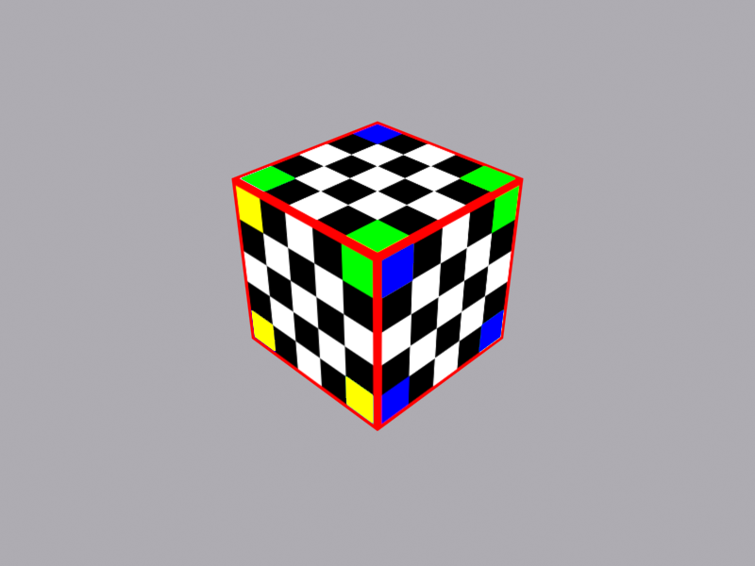
Bonus points
- Find the (outer) boundary pixels of the object image. Approximate the object boundary by a six-side polygon. Find the (s,) parameter of the six sides and identify them as the six peaks among the peaks obtained in Step 2.
- Group the lines into three groups based on theparameters of the lines.
- Sort the11parameters of each of the three line groups. The sixth value in each sorted list corresponds to an internal polygon side of an object face.
- Calculate the intersection points between the lines on each of the three faces.
- Draw the line segments with their end points.

